Manufacturing SOP: Surgical Mask Clip

Author: Mark Mellors Version 1 18 April 2020

# Purpose

To define:

* Process for cutting clips
* Precautions to prevent spread of COVID-19 by contamination of clips during manufacture and distribution
* Means of recording implementation of processes and precautions.

# Scope

Qualified staff/volunteers manufacturing the Addenbrooke’s approved design(s) of Surgical Mask Clips at MakeSpace, Mill Lane, Cambridge.

# Responsibilities

All:

* To ensure MakeSpace facility remains a “safe zone”, free of virus as far as possible
* Not to enter the MakeSpace facility if you show any symptoms that could indicate COVID-19, or you have been in recent contact with anyone showing symptoms.
* Report any symptoms that arise within 5 days of working in the MakeSpace facility to [cei@addenbrookes.nhs.uk](mailto:cei@addenbrookes.nhs.uk)

Supervisor:

* Ensure process is conducted according to SOP
* Document & report any non-conformances

Technician:

* Conduct cleaning, cutting and packaging as described
* Wear PPE as required.

# Hygiene Precautions

## Entry to workspace & Designation of Areas

Preventing the virus entering the workspace area is a high priority.

* All personnel will first enter “Contamination not controlled”
* On entry to this area, all personnel must remove outdoor clothing and store it in “Staff outer vestibule area”, NOT on the worktables
* All personnel must record time of entry and exit and sign a statement of general good health, stating duration of isolation and any potential opportunities for virus transmission - this will allow traceability in case of subsequent symptoms appearing
* Before entering the “Production Area”:
  + Use the “Prep Area” to wash hands thoroughly
  + Don PPE
* To transition back from the “Production Area” to “Dirty Goods In”
  + Use the “Prep Area” to doff PPE
* To enter or leave the “Contamination controlled”, you must observe the strict prohibition of the gangway.
* To protect operators, workstations are single operator only
* WIP parts must only be placed on the work surfaces labelled on the diagram
* The operator work stations mapped out (per the standardised work sheet below) have been positioned to allow a minimum of 2m clearance between operators to minimise operator cross-contamination risks.





## Personal Protective Equipment (PPE)

The intent of PPE in this context is to prevent virus from assembly staff contaminating the clips in production. This is important, since asymptomatic individuals can spread the virus through touch and respiration.

The following are to be worn while handling all parts:

* Disposable gloves - replace if removed
* Face masks - paper or fabric masks should be sufficient for this risk. Vented masks should have the valve sealed closed so exhaling is also filtered

# Equipment & Materials

## Equipment

* Laser cutters
* Cutting board
* Scalpel
* Scissors
* T7 screwdriver
* Steel weights x 4

## BoM Materials

* Custom Cote 0.457mm thick, A2 card
* Clean PE bag 300mm x 400mm
* 2 labels: producer and batch details Avery L4731

## Packaging BoM materials

* Bin bags
* 3” packing tape, Brown
* Labels 99mm x 67.5mm for postponed use-after date

## Consumables in production

* Permanent Pens labels for labelling
* Surgical masks, disposable or washable - sufficient for 1 mask per Technician per shift
* Disposable latex-free gloves - sufficient for 3 pairs per Technician per shift
* Cleaning cloths for all work surfaces
* Broom to remove production waste
* Mop & bucket

# Preparation of work areas and incoming goods

## 7.1 Cleaning work surfaces and equipment

## Work surfaces and equipment must be cleaned before each work session using routine cleaning and disinfection procedures (e.g., use cleaners and water to pre-clean surfaces then apply an EPA-registered, hospital-grade disinfectant). <https://www.epa.gov/pesticide-registration/list-n-disinfectants-use-against-sars-cov-2>

The process for cleaning the space is as follows:

1. Place cleaning materials on ‘Dirty Goods In’ work table
2. Enter ‘Hygeine and PPE’ area via the marked out gangway only
3. Wash hands for 20 seconds, put on PPE in following order:
   1. Overalls
   2. Surgical Mask
   3. Surgical gloves
4. Clean all work surfaces first with regular cleaning agents, followed by disinfectant
5. Clean all tools with appropriate cleaning wipes, then set them out in correct location as indication by the Production Layout Diagram
6. Return to the ‘Prep Area’ and:
   1. Remove gloves, place in bin
   2. Remove surgical mask, place in bin (if disposable type)
   3. Remove overalls

The area should be cleaned at the start of each work day, or if there is reason to believe the cleanliness of the space may have been compromised (e.g. entry of personnel not wearing correct PPE).

## 7.2 Goods receiving

Incoming goods should be logged and stored, but **not completely unpackaged**, in the “Incoming Goods” area.

Since viruses may remain viable for several days on surfaces, there is a risk that materials being brought into MakeSpace have been contaminated during distribution. Therefore, outer layers of packaging should be removed wherever possible before bringing materials into the production area.

If the product has not come in appropriate packaging, then it should be cleaned using a clean cloth and appropriate EPA approved disinfectant solution. Cardboard should preferably be left 24hours for virus contamination to become non-viable, rather than cleaning.

Ensure that ‘clean’ goods are placed immediately onto a ‘clean’ table in the ‘Production Area’.

The receipt of goods is traced by the batch history Gsheet, which records the date stamp, operator identification and assigns a unique transaction serial number to the activity.

# 7. Manufacturing process steps

The overall process is as in the diagram below.

A Batch Record is made electronically as work flows, and is mirrored by the packing labels. Traceability will allow us to decide what action to take in the event of an individual displaying symptoms shortly after assembly.

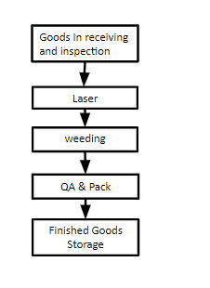

Material should flow around the workspace as follows:



## 

# Production Stages

## 7.1 Laser Cutting

In the production tracking software, take out a new lot number. Write this number onto the bag label with your initials, the date and the design designator. Place the label on the bag.

1. Place two sheets of card in the laser cutter, aligned with the alignment jig, and weigh down the corners with steel blocks
2. Laser cut card using cut file XXXA for design A or XXXB for design B
3. Remove sheets using a spare card sheet as a tray and place on weeding table

l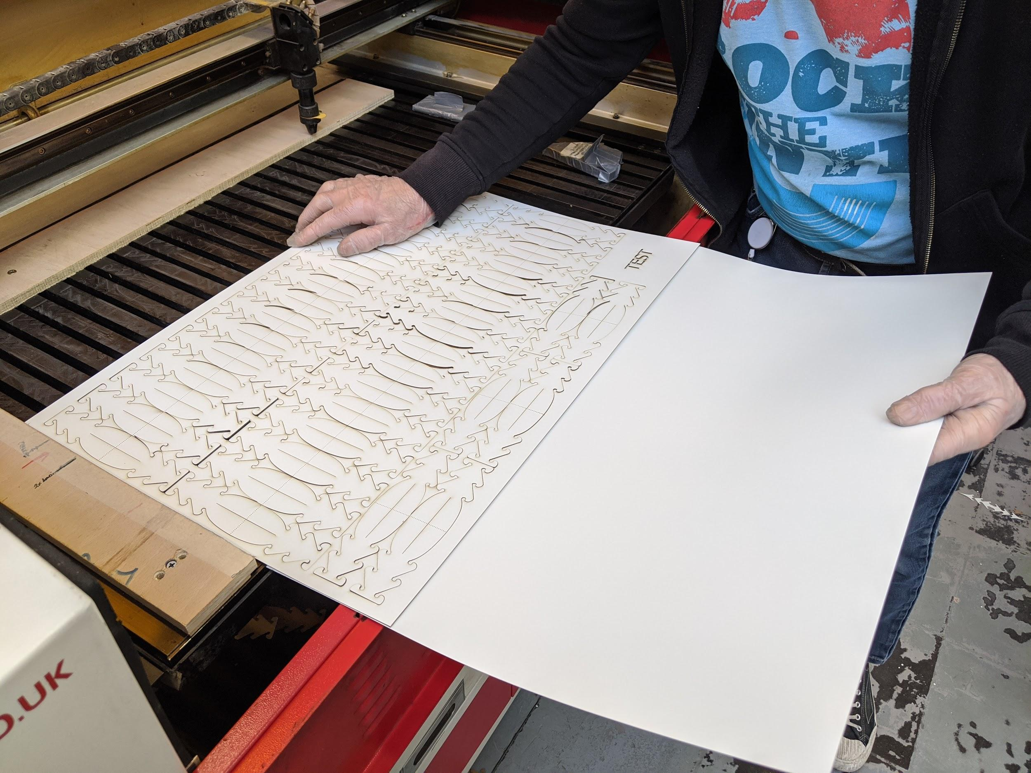

Laser cutter clearing using a spare sheet as a tray

## 7.2 Post Processing and QA

1. If weeder or QC worker different to cutter operator, record initials on appropriate bag label
2. Separate all clips from skeletal waste by lifting and shaking trim.
3. If still attached use scissors or scalpel to cut free (use cutting board for this).
4. Clear waste from all holes
5. Check clips for non conformance:
   1. Reject clips with deep scratches or marks on the card.
   2. Reject clips with excessive burn marks or staining (max 5mm acceptable).
   3. Reject clips with tears or missing features
   4. Reject clips that have touched the laser waste try, floor or other ‘dirty’ surface
   5. All holes to be clear.
6. Note number of sheets used for inclusion on label.

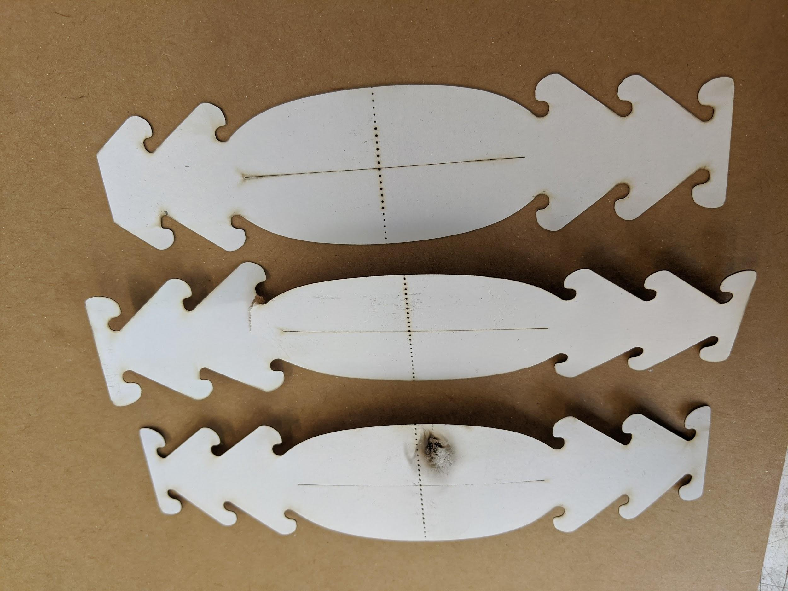

Example rejection faults on design A

## 

## 7.3 Packing

1. On the bag label, record the number of sheets worth of clips to be bagged (up to a maximum of 8)
2. Place clips in plastic bag, close bag

8 Labelling

The bagged clips are labelled directly with three labels, one to identify the producer, one to record its batch and one to provide instructions for use. They are:

Makespace Labels 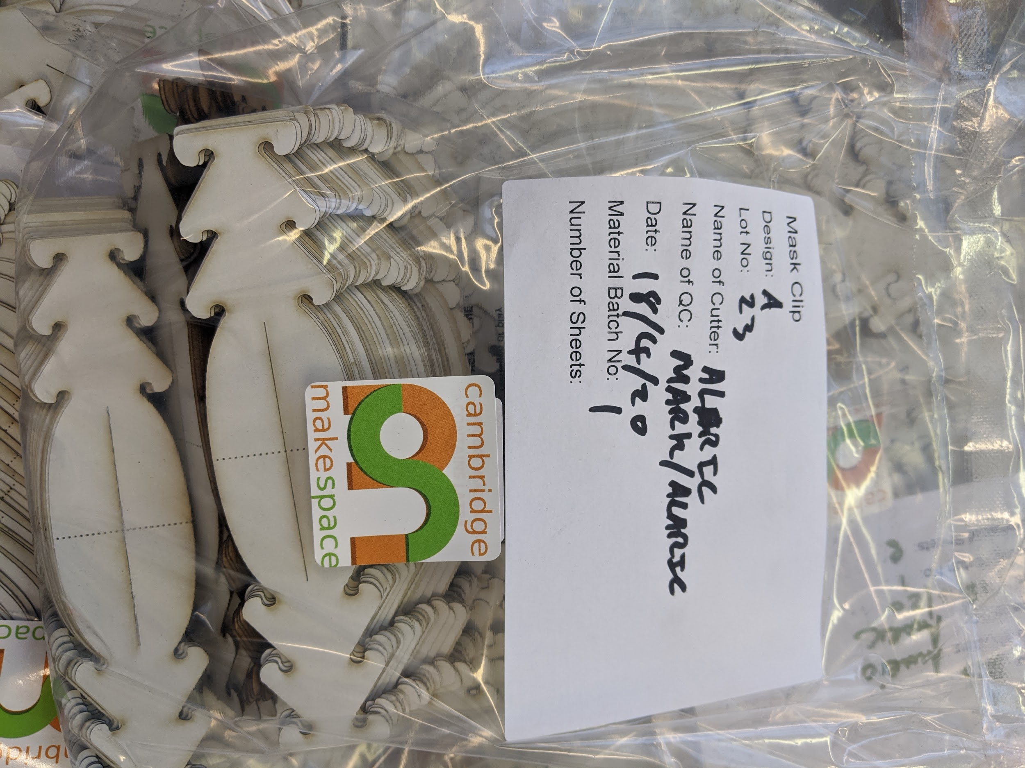

BagLabels.pdf 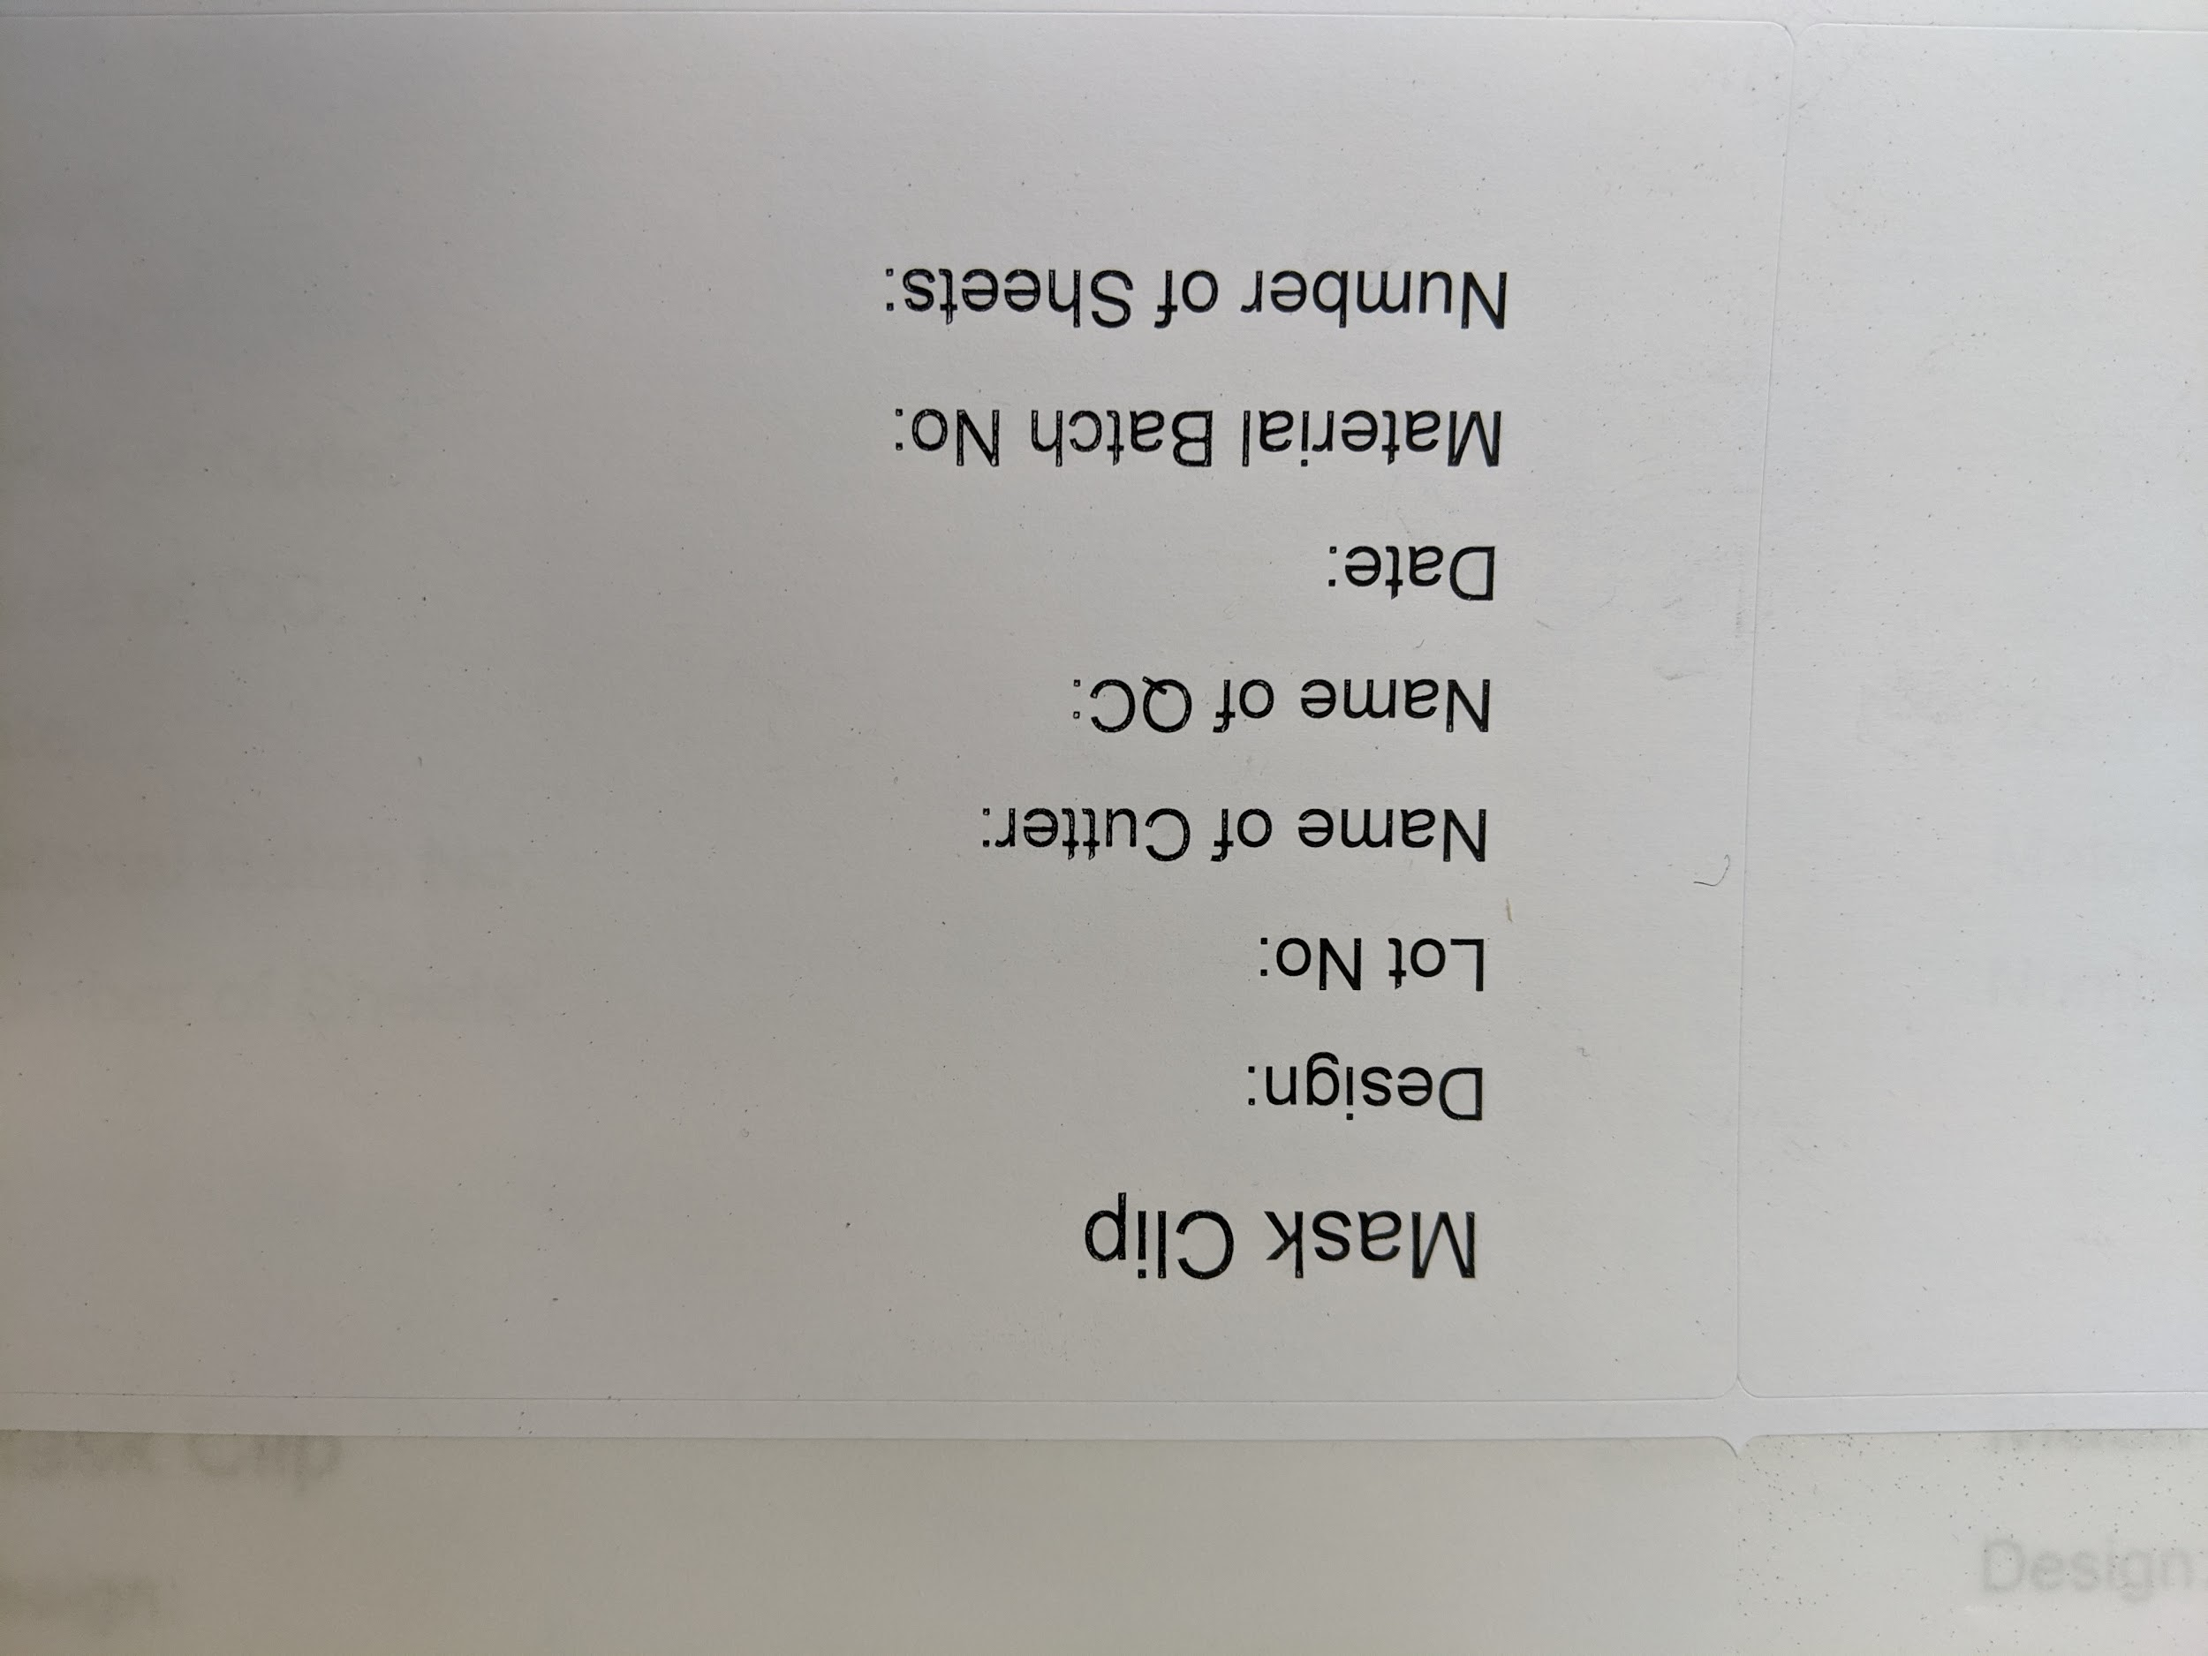

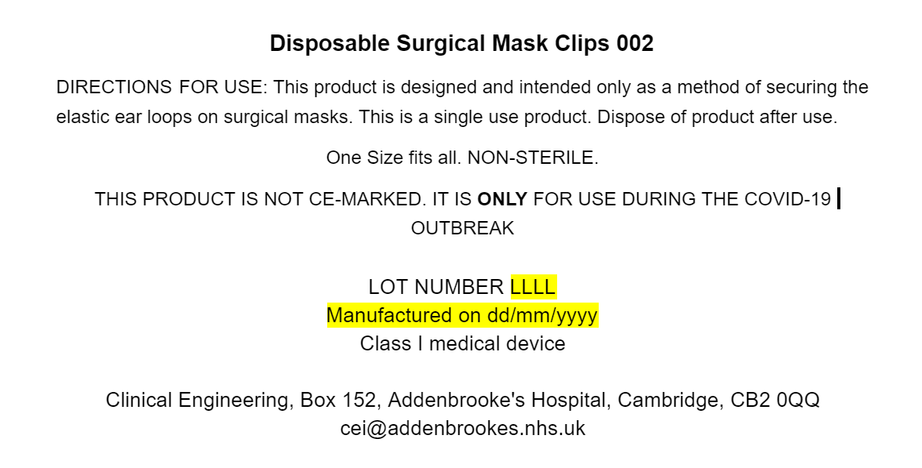

Manufacturer’s Instructions and Information (Google Doc)

# 9. Supporting Documents

* TBD

# 10. Change History

|  |  |  |
| --- | --- | --- |
| Version | Changes since previous version | Date / approver |
| 1 | Not applicable, first issue | 22 April 2020 / Abi Bush |
|  |  |  |

**Monitoring compliance with and the effectiveness of this document**

This process forms part of a quality system accredited to International Standard EN ISO 9001:2015, EN ISO 13485:2016 and BS 70000:2017. The effectiveness of the process will be monitored in accordance with the methods given in the Quality Manual (CE-QS-QAM-4).

**Equality and diversity statement**

This document complies with the Cambridge University Hospitals NHS Foundation Trust service equality and diversity statement.

**Disclaimer**

It is **your** responsibility to check against the electronic library that this printed out copy is the most recent issue of this document.

**Document management**

|  |  |  |  |
| --- | --- | --- | --- |
| Approval: |  | | |
| MDAG approval: |  | | |
| Owning department: | Clinical Engineering Innovation | | |
| Author(s): | Mark Mellors | | |
| Pharmacist: | n/a | | |
| File name: | Manufacturing SOP | | |
| Supersedes: | n/a | | |
| Version number: | 1.0 | Review date: | n/a |
| Local reference: |  | Document ID: |  |